Experiment 16
Compare different types Classification Algorithms and evaluate their performance.
Aim
To compare different classification algorithms in Python and evaluate their performance using accuracy score.
Program
# Compare Different Classification Algorithms

from sklearn.datasets import load_iris
from sklearn.model_selection import train_test_split
from sklearn.neighbors import KNeighborsClassifier
from sklearn.naive_bayes import GaussianNB
from sklearn.linear_model import LogisticRegression
from sklearn.metrics import accuracy_score

# Load dataset
data = load_iris()
X = data.data
y = data.target

# Split dataset
X_train, X_test, y_train, y_test = train_test_split(X, y, test_size=0.3)

# KNN
knn = KNeighborsClassifier()
knn.fit(X_train, y_train)
knn_pred = knn.predict(X_test)

# Naive Bayes
nb = GaussianNB()
nb.fit(X_train, y_train)
nb_pred = nb.predict(X_test)

# Logistic Regression
lr = LogisticRegression(max_iter=200)
lr.fit(X_train, y_train)
lr_pred = lr.predict(X_test)

# Accuracy
print("KNN Accuracy:", accuracy_score(y_test, knn_pred))
print("Naive Bayes Accuracy:", accuracy_score(y_test, nb_pred))
print("Logistic Regression Accuracy:", accuracy_score(y_test, lr_pred))
Output
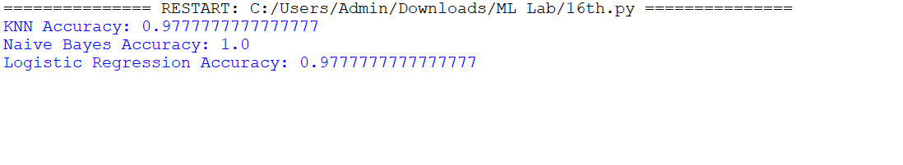

Result
The program successfully compared different classification algorithms (KNN, Naïve Bayes, and Logistic Regression) and evaluated their performance using accuracy scores.

